**Positioning Equinox+ for Growth: A Competitive Marketing Plan Against Peloton**

1. **Background**

Founded in 1991 in New York by the Errico family, Equinox began as a single upscale fitness club and quickly developed a reputation for luxury, innovation, and exclusivity. Over the next three decades, the brand evolved into a full-fledged lifestyle ecosystem, now operating over 100 locations worldwide (Equinox Group, 2024). Equinox is owned by the Equinox Group, which also manages SoulCycle, Blink Fitness, PURE Yoga, and Equinox Hotels. It caters primarily to high-income, urban professionals seeking a holistic approach to fitness that includes personal training, group fitness, spa treatments, recovery programs, and curated nutrition and lifestyle services. This positioning has made it synonymous with aspirational wellness and cultural capital (McMillanDoolittle, 2023).

In contrast, Peloton represents a newer, tech-driven approach to fitness.Peloton was founded in 2012 by John Foley, Tom Cortese, Graham Stanton, Yony Feng, and Hisao Kushi. The company launched on Kickstarter and introduced its first bike in 2014, blending high-end hardware with live and on-demand classes. Peloton created a highly personalized experience powered by charismatic instructors, real-time tracking, and engaging content. The brand expanded beyond cycling into treadmills, rowing machines, strength training, and meditation, supported by a robust digital platform. Today, Peloton has operations in the United States, Canada, the United Kingdom, Germany, and Australia, and recently announced plans to enter Austria. Its content platform, the Peloton App, is available in over 160 countries, enabling the brand to reach a wide and diverse audience far beyond its hardware user base (Peloton, 2024).

COVID-19 exposed the stark differences between Equinox and Peloton’s business models. As lockdowns shuttered gyms worldwide, Equinox—heavily dependent on in-person experiences—was forced to close all locations, disrupting its revenue stream. Although it later launched the Equinox+ app, its digital presence remained comparatively nascent. Peloton, on the other hand, was well positioned to meet the surge in demand for at-home workouts. Its subscriber base more than doubled in 2020, with record-breaking hardware sales and app engagement (Sheth, 2023). Peloton became a household name, especially among suburban families and busy professionals seeking structure and motivation at home.

In the post-pandemic landscape, both brands are undergoing strategic repositioning. Equinox is reinforcing its experiential luxury advantage while enhancing its digital offerings to support a hybrid model that meets evolving consumer needs. Equinox+ now offers on-demand content, virtual classes, and wellness guidance, but emphasizes its curated, high-touch physical environments as a core differentiator.

Peloton is adapting to a new era of growth stabilization, facing challenges including hardware saturation, leadership turnover, and increased competition. To remain competitive, Peloton has introduced app-only tiers, broadened its content across fitness modalities, and deepened retail and brand partnerships with companies like Lululemon, Amazon, and Target (Businesswire, 2023).

Together, Peloton and Equinox represent two ends of the premium fitness spectrum: one rooted in digital access and community-led engagement, the other in luxury, exclusivity, and physical space. Their respective evolutions offer a lens into how the fitness industry is responding to a more flexible, emotionally driven, and tech-integrated consumer base. Understanding these shifts is essential to crafting a marketing strategy that resonates in today's hybrid wellness economy.

**II. Market Assessment**

**Equinox:** Equinox operates in the premium fitness and wellness space, historically defined by high-touch, in-person services and elite brand positioning (McMillanDoolittle, 2023). However, the rapid growth of digital-first fitness models, accelerated by the COVID-19 pandemic, prompted Equinox to extend its offering through the launch of Equinox+, its digital platform (Braze, 2023). While the app demonstrates potential, it remains supplementary to the brand’s core value proposition, revealing persistent challenges in scaling a fully integrated digital experience (BrandVM, 2023). See Appendix I, Exhibit 1 for a detailed SWOT analysis of Equinox.

**Peloton:** Peloton redefined the fitness category by pairing high-end, connected fitness hardware with a subscription-based content platform focused on live and on-demand instruction, motivation, and digital community. This model propelled Peloton to the forefront of the industry during the pandemic, when demand for at-home wellness solutions spiked. However, as consumer behavior shifts and hardware saturation sets in, Peloton is repositioning itself as more than a bike company by leaning into app-first strategies, diversified modalities, and subscription-only growth (Retail Dive, 2023). See Appendix I, Exhibit 2 for a detailed SWOT analysis of Peloton.

**Competitive Analysis**

Equinox and Peloton operate within the dynamic and increasingly hybrid wellness industry, but they cater to distinct consumer mindsets. Equinox focuses on luxury, exclusivity, and spatial experience, competing with boutique studios such as Barry’s and Life Time Fitness. Its challenge lies in expanding beyond physical spaces and translating its brand prestige into a compelling digital product.

Peloton, on the other hand, thrives on accessibility, technology, and community-driven content. It competes directly with connected fitness services like Apple Fitness+ and emerging digital-first platforms on YouTube and Instagram. Although Peloton’s initial edge stemmed from its proprietary hardware and exclusive content, this advantage is narrowing as competitors offer comparable features at lower costs.

Strategically, Equinox excels in delivering aspirational in-person experiences, while Peloton democratizes wellness through personalized, flexible access at scale. Both brands are now converging, with Equinox moving into digital territory and Peloton exploring offline and lifestyle touch points as they attempt to future-proof their relevance.

**5 C’s: Equinox vs. Peloton**

| **Factor** | **Equinox** | **Peloton** |
| --- | --- | --- |
| **Company** | Elite wellness brand branching into hotel & lifestyle; digital still nascent | Digital-first fitness innovator with smart hardware, app ecosystem, & expanding modalities |
| **Customers** | Upscale professionals seeking exclusivity, design, and social connection | Busy professionals/ hybrid workers prioritizing convenience, flexibility, & goal tracking |
| **Competitors** | Boutique fitness studios, premium gyms, wellness retreats | Apple Fitness+, iFIT, YouTube creators, low-cost fitness apps |
| **Collaborators** | Hospitality brands, luxury wellness, and fashion partners | Lululemon, Nordstrom, Amazon, corporate wellness providers |
| **Context** | Facing economic shifts, digital change, and evolving luxury demands | Addressing post-pandemic plateau, app fatigue, and increased market saturation |

Equinox and Peloton are emblematic of two opposing yet converging fitness paradigms.

Equinox represents high-touch, high-design physical experiences, while Peloton symbolizes accessible, tech-driven community fitness. As consumer expectations evolve toward personalization, flexibility, and holistic wellness, both brands must reimagine their value propositions. Success will depend on how well they can adapt their core strengths to a hybrid future by balancing exclusivity with accessibility and physical presence with digital immersion.

**III. Insights**

In order to develop meaningful and competitive recommendations for Equinox, it is essential to ground strategy in real consumer behaviors and evolving wellness trends. Today’s fitness consumers are no longer motivated solely by convenience or results, they seek emotional connection, lifestyle alignment, and experiences that contribute to their broader sense of identity and well-being. The following insights, drawn from recent industry reports and behavioral studies, illuminate the values, preferences, and psychological drivers shaping the modern wellness economy.

**1. Emotional Drivers & Identity-Based Wellness**

* **Wellness as a Way of Life:** Consumers, especially millennials and Gen Z, are increasingly viewing wellness as a holistic lifestyle priority. According to McKinsey & Company (2024), 82% of U.S. consumers see wellness essential to daily life, including physical, mental, and emotional health.
* **Community is the Commitment:** A strong sense of belonging significantly drives fitness engagement. McKinsey & Company (2022) found that people are more likely to stick with wellness routines when they feel emotionally connected to a space or peer group.
* **Purpose Over Performance:** Emotional motivators like transformation, achievement, and social influence fuel consumer choices in the wellness space. Media Culture (2023) shows people crave fitness experiences that support identity and personal growth.
* **Feelings Drive Buying:** Emotional needs like confidence, self-worth, and social approval often outweigh functional perks in shaping consumer behavior. Brands that connect on a deeper level inspire stronger loyalty (GreenBook, 2023).
* **Aesthetic as Identity:** Trends like the “pink pilates princess” reveal how fitness is becoming an avenue for identity expression. Vogue Business (2023) notes younger consumers seek brands that mirror their values, lifestyle, and social media persona.

**2. Personalization & Customization**

* **Custom Fit, Lifelong Loyalty:** 90% of consumers seek personalized wellness plans, and over half are willing to share their health data to get them. Tailored experiences deepen emotional bonds and boost long-term engagement (PA Consulting, 2024).

**3. Tech-Enabled Wellness & Hybrid Innovation**

* **Digital First, Emotional Second:** Consumers are gravitating toward digital-first wellness platforms that emphasize flexibility, convenience, and accessibility, while still building strong community connections (PwC, 2024).
* **Hybrid is Here to Stay:** The rise of hybrid fitness models—offering both in-person and virtual options—caters to diverse preferences and packed schedules. Over 65% of fitness consumers now use hybrid or virtual formats (Future Market Insights, 2025).
* **There’s an App for That:** Mobile fitness apps have become a core part of workout routines. With over 850 million downloads globally in 2023, their popularity shows no signs of slowing (Business of Apps, 2025).
* **Tech that Talks Back:** Wearable fitness tech paired with apps delivers real-time data and feedback, helping users stay motivated and on track, driving higher retention for programs using these tools (Wegile, 2024).

**IV. Strategic Direction and Target Audience**

**Equinox Target Market and Demographics:** Equinox employs a focused segmentation strategy targeting affluent, urban professionals who prioritize luxury, exclusivity, and a holistic approach to wellness. The brand's clientele typically comprises high-income individuals residing in metropolitan areas, who view fitness as an integral component of their lifestyle and personal identity. This demographic is characterized by a willingness to invest in premium services that offer a comprehensive wellness experience, encompassing not only physical fitness but also nutrition, recovery, and mental well-being (McMillanDoolittle, 2023).

To effectively reach this niche market, Equinox strategically locates its clubs in upscale

neighborhoods within major cities such as New York and Los Angeles. This “land and expand” approach allows the brand to establish a strong presence in key markets before broadening its reach within those areas (BrandVM, 2023). By situating its facilities in affluent locales, Equinox ensures proximity to its target audience, thereby enhancing convenience and accessibility for members.

Equinox's marketing efforts are meticulously crafted to resonate with its target demographic. The brand's campaigns often emphasize themes of aspiration, sophistication, and transformation, appealing to consumers who seek more than just a gym membership. Campaigns like “Life is the Luxury” underscores the brand's commitment to providing an elevated lifestyle experience (BrandVM, 2023). Moreover, Equinox leverages data analytics to personalize member experiences, delivering tailored content and communications, resulting in a 150% increase in member engagement both in-club and online (Braze, 2023).

In 2023, Equinox launched the controversial “We Don’t Speak January” campaign. Equinox claimed that 70% of individuals who join gyms as part of New Year's resolutions eventually halt visits, so they differentiated themselves by not accepting new members on January 1st. This was Equinox’s way to signal that they are a brand for whom fitness is a lifestyle and that they seek the committed. They state 95% of their members remain with Equinox: their members are dedicated to the Equinox lifestyle. While the campaign resonated with Equinox’s core audience, it drew criticism from some for appearing exclusionary, potentially discouraging newcomers to fitness. Nonetheless, the controversy drew media coverage and website traffic, raising awareness of Equinox as a result (We Are Collins, 2023).

In addition to its core fitness offerings, Equinox has expanded into related sectors, such as hospitality and travel, to further cater to its clientele's lifestyle preferences. The launch of the Equinox Hotel in New York City and curated travel experiences to destinations like Morocco exemplify the brand's commitment to providing comprehensive wellness solutions that align with the aspirations of its members (McMillanDoolittle, 2023).

**Peloton Target Market and Demographics:** Peloton adopts a multifaceted segmentation strategy that combines demographic, psychographic, and behavioral elements to appeal to a broad spectrum of consumers. Initially targeting affluent, tech-savvy individuals seeking convenient at-home workout solutions, Peloton has since expanded its focus to include a wider audience, emphasizing accessibility and community engagement (Aubrey Marketing, 2023).

The brand's primary demographic comprises middle-aged, health-conscious professionals who value efficiency and flexibility in their fitness routines. Peloton's offerings cater to this segment by providing a diverse range of live and on-demand classes accessible through various devices, allowing users to integrate workouts seamlessly into their daily schedules (ResearchGate, 2021). Additionally, Peloton's emphasis on community, facilitated through features like leaderboards and instructor shout-outs, fosters a sense of belonging and motivation among users (CourseSidekick, 2023).

Peloton's marketing strategies are designed to resonate with its diverse customer base. The brand's campaigns often highlight personal transformation and empowerment, appealing to individuals seeking to improve their health and well-being. For example, the “Before, Meet After” campaign showcases real users’ fitness journeys, emphasizing the attainable nature of personal growth through Peloton's platform (Aubrey Marketing, 2023).

In 2023, Peloton had a relaunch, reintroducing itself as an “everywhere brand” rather than continuing to pigeonhole itself as an in-home brand. Peloton initially focused on cycling, but app data revealed that more than half of user workouts now involve other modalities. In the attempt to include all ages regardless of experience, they modified their membership tiers to include free content, workouts that can be done with or without equipment, and workouts that can be performed at home, outdoors, or in the gym (Peloton, 2023).

To further broaden its appeal, Peloton has introduced more affordable subscription options and expanded its content offerings to include non-cycling classes, such as strength training, yoga, and meditation. This diversification allows the brand to attract new segments, including those who may not have previously considered Peloton due to cost or equipment constraints (ResearchGate, 2021).

Additionally, Peloton's strategic partnerships and retail presence in high-end malls and lifestyle centers enhance its visibility among potential customers (CourseSidekick, 2023). For example, in 2023, Peloton and Lululemon partnered together for five years in an attempt to expand their customer reach. Lululemon co-brands apparel for Peloton, includes Peloton content within its app, and offers discounts on Peloton merchandise to Lululemon members. Meanwhile, Peloton promotes Lululemon clothing in its content (Businesswire, 2023). In another attempt to expand customer reach, Peloton has branched out its third-party retail partnerships to capture the 42% of clothing and fashion shoppers (37% for searches and 24% for purchases) who use online third-party marketplaces, according to eMarketer. By collaborating with Nordstrom, Costco, and Target, where Peloton apparel and bike bundles are sold, Peloton makes itself more widely accessible (Retail Dive, 2025).

**V. Brand Positioning**

**Equinox Brand Positioning:** Equinox has carved out a distinct identity as a luxury fitness and lifestyle brand, appealing to a selective audience that values exclusivity, sophistication, and total well-being. Setting itself apart from other gyms, Equinox markets a full-spectrum wellness experience, one that blends fitness, recovery, nutrition, and personal style under the unifying ethos conveyed by the tagline “It’s not fitness, it’s life” (BrandVM, 2023). Its facilities are outfitted with cutting-edge equipment and premium amenities, while its high-concept marketing campaigns are tailored to urban professionals who view health as a form of self-expression and status. Campaigns like the *“*Want It All” advertisement (Appendix II, Exhibit 1) and elevated visual identity from Equinox’s brand guidelines (Exhibits 4 & 5) illustrate a commitment to high-concept, fashion-inspired storytelling that aligns the brand more closely with luxury fashion and cultural capital than traditional fitness marketing.

With services like spa rituals, personal training, exclusive wellness products, and curated lifestyle amenities, Equinox goes beyond physical exercise to offer a fully immersive and aspirational brand experience. Recent visual promotions (Exhibits 8 & 9) further underscore this aesthetic with imagery that presents Equinox spaces as both serene and opulent, where “iconic” design meets peak performance. According to Equinox’s internal brand philosophy (Exhibit 3), the brand intentionally uses emotional tension and provocation to signal ambition and seduction, creating a space that is deliberately not for everyone. This carefully crafted experience reinforces its image as the pinnacle of fitness culture for a high-performing, image-conscious clientele (Jordan Bean, 2023; Equinox Careers, n.d.).

**Rational Benefit**: Equinox delivers access to world-class training environments, expert coaching, and a diverse array of group fitness options. By integrating nutritional guidance, spa services, and recovery technologies, it offers a complete wellness solution for those with exacting personal standards (Equinox Careers, n.d.).

**Emotional Benefit:** The brand resonates with individuals who equate luxury and self-discipline with success. Its elite social environment and sophisticated design language provide a strong emotional reward: a sense of status, alignment with excellence, and personal transformation that feels not just earned, but curated (Equinox, 2022; Exhibit 9).

**Reason to Believe:** Equinox’s long-standing reputation is built on consistent delivery of high-quality services and elevated brand storytelling. Its commitment to visual refinement (Exhibit 4), provocative messaging (Exhibit 1), and elite experiences has solidified its position as a symbol of luxury health, and performance (Aziz, 2023).

**Peloton Brand Positioning:** Peloton has evolved into a leading digital fitness brand that makes high-quality, interactive workouts accessible to users wherever they are. Originally known for its sleek indoor cycling bikes, the company has grown into a broader wellness ecosystem that pairs advanced hardware with immersive, on-demand content. Its messaging now emphasizes flexibility, inclusivity, and transformation, reinforced by the tagline “for everyone, everywhere” (Brand Innovators, 2022). Through its app, users can engage in thousands of classes across multiple modalities, including strength training, yoga, HIIT, and meditation, with or without owning Peloton hardware (Retail Dive, 2022).

Peloton’s brand campaigns blend emotional storytelling and self-improvement, using before-and-after transformation imagery (Exhibit 6), motivational copy (e.g., “Once you begin, you're no longer a beginner,” Exhibit 5), and community-focused design features like leaderboards, metrics, and shout-outs (Empathy Marketing, 2022). The brand’s internal brand wheel (Exhibit 7) emphasizes entry points across motivation, identity, and connectivity, reflecting a deep awareness of users’ emotional drivers and goals. Compared to Equinox’s exclusivity, Peloton offers empowerment through access: the idea that personal growth and connection can be achieved anywhere, by anyone, at any time — with enough encouragement, structure, and support.

**Rational Benefit:** Peloton offers a high-value digital platform that integrates hardware and

software into one seamless experience. Its on-demand classes, expert instructors, and real-time performance tracking make it a robust and customizable home fitness system (Peloton Interactive, 2023).

**Emotional Benefit:** Peloton emphasizes community, consistency, and personal progress. Whether through instructor connection or digital social features, the experience fosters motivation and belonging, inspiring users to commit to goals and celebrate growth (Rutledge, 2020; Exhibit 5).

**Reason to Believe:** Peloton’s consistent innovation and brand reinvention, supported by high retention rates and an engaged subscriber base, validate its promise of transformation. Its layered emotional storytelling, multi-channel campaigns (Exhibit 2, Exhibit 6), and strategic positioning within the connected fitness space provide ongoing proof of brand relevance and impact (Peloton, 2022).

**VI. Equinox+ Marketing Plan Recommendation***Positioning Equinox+ as the premier luxury digital wellness platform through holistic experiences, personalization, and strategic expansion.*

**1. Marketing Plan Goals: Expand the Equinox+ Wellness Universe** I designed a plan to strategically position Equinox+ as the leading destination for digital luxury wellness. It seeks to leverage the brand's equity, respond to gaps in competitor offerings (namely Peloton), and meet growing consumer demand for high-end, integrated, and personalized digital wellness experiences. My goals include:

* Capitalizing on Equinox’s strength in luxury fitness and holistic lifestyle branding
* Differentiating from Peloton’s fitness-first approach by expanding into mental wellness, lifestyle services, and exclusive retreats (unlike Peloton’s narrower product suite, Equinox+’s holistic focus positions it as a more complete, elevated lifestyle ecosystem)
* Scaling Equinox+’s reach into digital-first and non-club markets while reducing churn and increasing engagement

**2. Situation Analysis: Market Context and Strategic Opportunity**

Equinox+ currently faces the challenge of under-leveraging its digital capabilities, which limits engagement and growth in non-club markets. At the same time, Peloton has established a strong foothold in the digital wellness category with competitively priced offerings and a highly accessible user experience. This presents both a threat and an opportunity. The key threat lies in Peloton’s ability to scale rapidly through mass-market pricing and a singular focus on digital fitness. However, Equinox+ can differentiate itself by expanding into a broader wellness space that includes lifestyle content, mental well-being, and exclusive services.

The strategic opportunity is clear: by delivering a more curated, premium experience, Equinox+ can attract high-value consumers who are underserved by current fitness platforms. Personalization, exclusivity, and holistic wellness integration will be the levers that allow Equinox+ to redefine the category and win market share.

**3. Target Market & Demographics**

Equinox+ will target three primary consumer segments that present high potential for growth, engagement, and brand alignment. The first group includes previous Equinox in-club members who have paused or canceled their memberships in favor of more convenient, at-home digital fitness options such as Peloton. These individuals already understand the Equinox brand’s value proposition and likely remain brand-affiliated, making them prime candidates for reactivation through a high-quality, digitally delivered version of the luxury experience they once enjoyed in person. By offering enhanced digital personalization and access to holistic services beyond workouts, Equinox+ can re-engage this lapsed segment and recapture lost share from Peloton’s migration.

The second target segment consists of affluent urban consumers living in cities and wellness-focused regions that do not currently have a physical Equinox club presence. These markets include hubs like Austin, Charlotte, Denver, and Nashville, areas experiencing rapid growth in wellness culture and spending power. For this audience, Equinox+ serves as the only accessible entry point to the brand. By offering a rich, digital-first experience rooted in luxury wellness, the platform enables these consumers to participate in the Equinox lifestyle regardless of geography. This supports geographic expansion while strengthening brand reach and equity.

The third segment includes digitally native fitness consumers who currently use platforms like Peloton, Apple Fitness+, or Centr, but are open to trading up for a more elevated, personalized, and aspirational offering. These users are highly engaged in wellness but may find existing platforms lacking in depth, exclusivity, or cross-category integration. Equinox+’s promise of elite wellness, concierge-level care, and curated lifestyle content offers a compelling upgrade. This group represents a key competitive battleground where Equinox+ can win by amplifying its brand prestige and leveraging the growing demand for personalization in wellness.

Together, these three audiences represent a powerful intersection of brand familiarity, market opportunity, and aspirational demand. Unlike Peloton’s broad mass-market approach, Equinox+ focuses on quality over quantity, targeting users who are both more likely to pay a premium and more likely to remain loyal over time.

**4. Strategic Positioning**

Under the brand promise “Elite Wellness. Everywhere,” Equinox+ will be positioned as the premier luxury digital wellness platform. This strategy emphasizes exclusivity, personalization, and holistic health as core pillars. Unlike competitors focusing solely on physical fitness, Equinox+ offers a holistic lifestyle experience that integrates fitness, self-care, mental well-being, and experiential wellness.

This unique positioning enables the platform to engage users at every point in their wellness journey. From on-demand classes to immersive retreats, Equinox+ offers a seamless, elevated experience supporting transformation and ongoing growth, making Equinox not just a product, but a lifestyle partner.

**5. Tactics**

* **Tiered Membership Model:** I recommend implementing a two-tier membership model. The Vital tier ($40/month) offers access to a robust digital library of fitness and wellness content, curated product recommendations, and hotel travel perks. The Prestige tier ($200/month) provides concierge-level experiences including one-on-one expert sessions, custom wellness programs, skincare and nutrition planning, mental health check-ins, and access to exclusive retreats. This tiered model allows the platform to compete with Peloton at the entry level while unlocking deeper value and retention through premium service for high-end consumers.
* **Content Expansion Strategy:** To differentiate from fitness-only competitors, Equinox+ will expand its content to include classes on stress management, breathwork, mindfulness, emotional wellness, and sleep. New formats for interactive live classes, Q&A sessions, and expert workshops will ensure content remains dynamic and engaging. These offerings deepen user engagement and reflect a more complete vision of well-being, setting Equinox+ apart in a crowded market.
* **Personalized Wellness Experiences:** Equinox+ will offer one-on-one sessions with a network of holistic wellness professionals, including therapists, nutritionists, and doctors. These services will be mirrored digitally with customized training and self-care programs. Enhanced user profiles will allow for tracking progress, setting goals, and receiving personalized recommendations, ensuring dynamic, evolving support that encourages long-term engagement.
* **Exclusive Travel and Retreats:** Prestige members will gain access to immersive wellness retreats hosted at Equinox Hotels and like-minded partner resorts. These experiences will integrate mental and physical programming in luxury settings. Booking will be facilitated through the Equinox+ platform, reinforcing seamless user experience and brand cohesion. This tactic creates a premium lifestyle offering that Peloton currently cannot replicate.
* **Expert Ambassadors and Facilitators:** Equinox+ will elevate credibility and cultural cachet by partnering with top-tier trainers, thought leaders, and facilitators to develop exclusive content. These experts will also lead in-app and in-person events, serve as brand ambassadors, and drive awareness through social platforms. By integrating talent into the product and promotion strategy, Equinox+ enhances both engagement and brand equity.
* **Advertising and Community Engagement:** Equinox+ will roll out a multi-channel advertising campaign targeting affluent urban and wellness-forward non-club markets. Channels will include social media, digital search/display, out-of-home (OOH), and high-end print (Appendix III, Exhibits 10-12). Additionally, Equinox+ will launch the new Expert Content Series on in-house social accounts and key ambassador accounts. Equinox+ will instate a peer-to-peer referral program offering three free months to new members recommended by an existing member. Additionally, influencer partnerships will boost engagement, expand reach, and add authenticity to the brand.

**6. KPIs: Success Metrics**

To evaluate performance, Equinox+ will track four core KPIs over a 12-month period. The first is a target of acquiring 100,000 new subscribers (from the current base of 350,000). The second is securing 60% of these signups from non-club markets, confirming geographic and demographic expansion. Third, a 25% reduction in digital churn will reflect stronger personalization and member satisfaction. Finally, a 40% increase in app engagement will serve as evidence of effective content deepening and platform stickiness. Together, these KPIs demonstrate how the marketing strategy will scale Equinox+ sustainably while cultivating deeper, more valuable user relationships, a key edge over competitors like Peloton.

**7. Conclusion: The Four P’s**

* **Product:** Equinox+, a high-touch multi-tier digital wellness platform, delivers concierge-style service, expert coaching, exclusive retreats, and holistic lifestyle content. This robust product ecosystem addresses far more than physical fitness, creating sustained value for premium users.
* **Price:** With two pricing tiers, Equinox+ balances accessibility and exclusivity. The Vital tier ($40/month) is priced to compete directly with Peloton, while the Prestige tier ($200/month) unlocks elite experiences that command higher loyalty and margin.
* **Place:** The platform is available through the Equinox+ app across mobile, tablet, and desktop, ensuring frictionless access. Geographic expansion is supported by targeted advertising in high-opportunity, non-club markets.
* **Promotion:** Equinox+ will drive awareness and acquisition through digital and traditional media, influencer collaborations, and a referral program. The Expert Content Series and strategic ambassador partnerships will build authority and increase cultural relevance.

This marketing plan positions Equinox+ to dominate the luxury digital wellness space. Through strategic investments in personalization, lifestyle expansion, and exclusive experiences, the brand can effectively compete with Peloton while capturing a unique, high-value segment of the market.

**Appendices**

Appendix I

**Exhibit 1. SWOT Analysis – Equinox**

| **Strengths**   * Premium brand equity and aspirational positioning * Diversified portfolio (clubs, SoulCycle, Equinox Hotels, Equinox+) * High loyal consumer base * Industry-leading facilities, training, & spa amenities | **Weaknesses**   * High membership cost * Geographic limitations (BrandVM, 2023) * Slow adoption of digital innovation (Braze, 2023). * Dependence on physical experiences |
| --- | --- |
| **Opportunities**   * Expansion into international luxury markets * Wellness integration (nutrition, recovery, mental fitness) * Strategic corporate & hospitality partnerships * Development of personalized digital coaching & AI-powered features | **Threats**   * Economic sensitivity impacting discretionary spending * Competition from boutique studios & hybrid wellness brands * Evolving consumer preference for flexibility * Pushback against perceived exclusivity |

**Exhibit 2.** **SWOT Analysis – Peloton**

| **Strengths**   * Strong brand loyalty & highly engaged user base * Integrated ecosystem of hardware, software, & content * Rich community features (leaderboards, shoutouts, milestones) * Expansive content library across fitness verticals * Advanced personalization & progress tracking tools | **Weaknesses**   * High upfront cost for equipment & accessories * Heavy dependency on hardware revenue * Declining post-pandemic demand * Internal operational challenges & leadership changes |
| --- | --- |
| **Opportunities**   * Growth of app-only subscription tiers * Expansion into new global markets * New product categories (strength, rowing, meditation) * B2B opportunities via corporate wellness programs | **Threats**   * Intense competition from Apple Fitness+, iFIT, & low-cost digital platforms * Macroeconomic uncertainty & shifting consumer budgets * Decreasing differentiation as competitors catch up in content & tech * Platform fatigue & reduced digital novelty |

Appendix II



Exhibit 1 – **Equinox. (2024).** *Want it all campaign [Advertisement]*. <https://www.equinox.com/landing/litl>

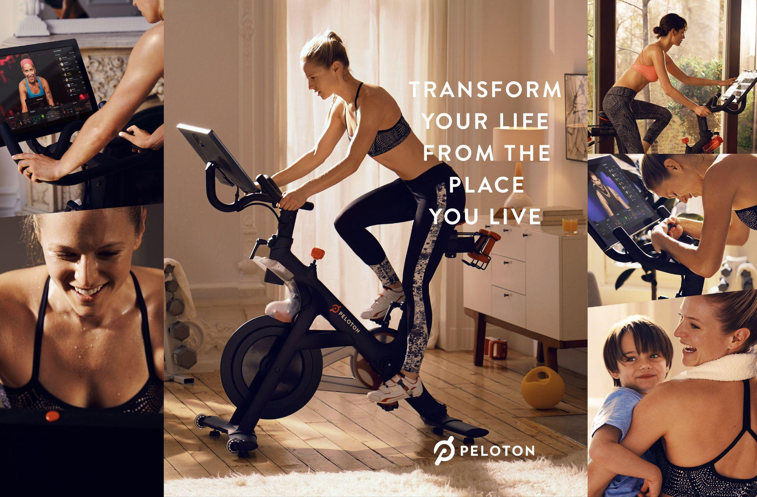

Exhibit 2 – **Peloton. (2020).** *Transform your life from the place you live [Advertisement]*. <https://www.onepeloton.com/>



Exhibit 3 – Equinox Brand Guidelines – Visual Identity and Content Philosophy (Equinox, 2022)



Exhibit 4 – Equinox Brand Guidelines – Visual Identity and Content Philosophy (Equinox, 2022)



Exhibit 5 – **Peloton. (2023).** *Once you begin, you’re no longer a beginner [Advertisement]*. <https://www.onepeloton.com/>

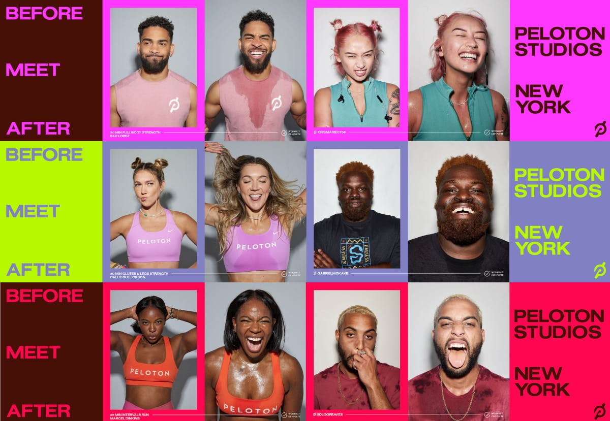

Exhibit 6 – **Peloton. (2023).** *Before, meet after: Peloton Studios New York campaign [Advertisement]*. <https://www.onepeloton.com/>

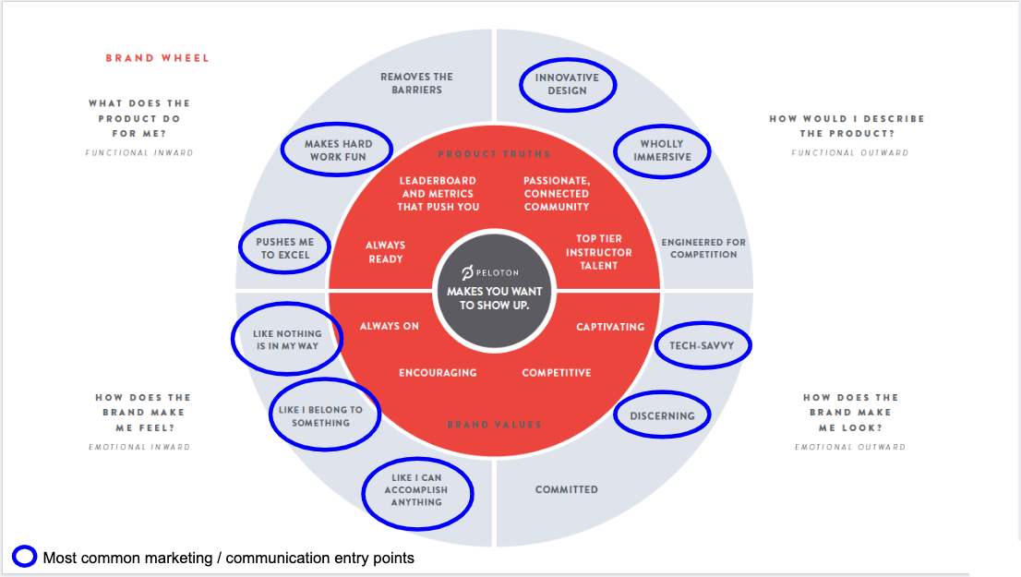

Exhibit 7 – **Peloton. (2022).** *Peloton brand wheel: Marketing and communication entry points [Diagram]*. <https://www.onepeloton.com/>

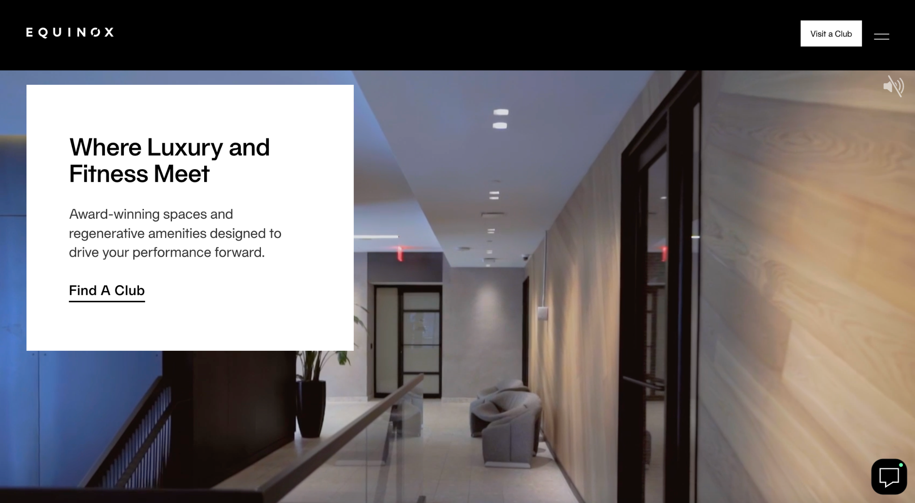  
Exhibit 8 – **Equinox. (2025)**. *[Web page visual]*.<https://www.equinox.com/clubs>

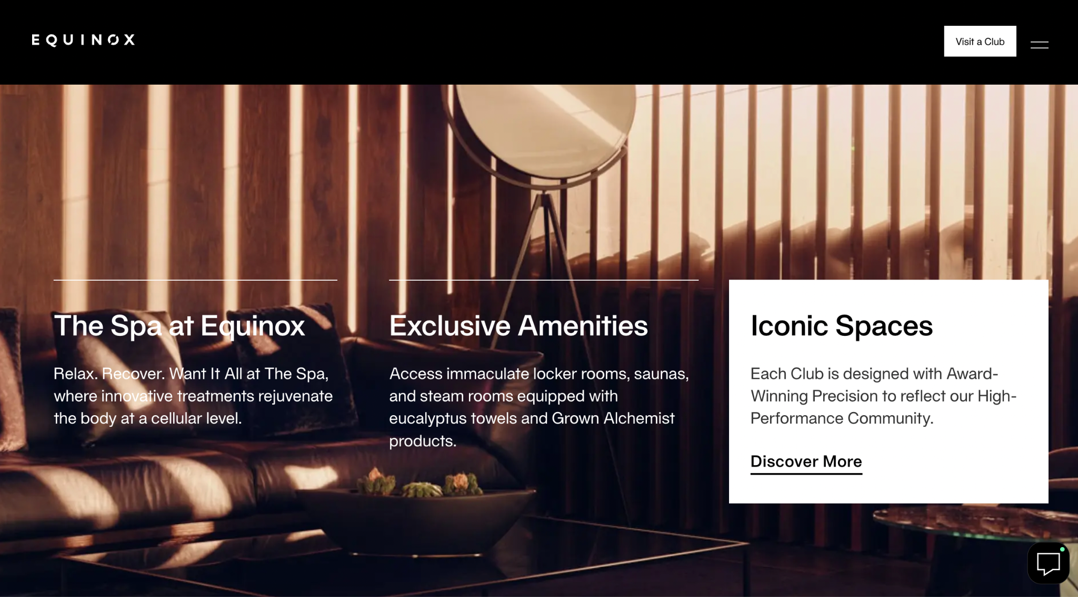

Exhibit 9 – **Equinox. (2025)**. *[Web page visual]*.<https://www.equinox.com/clubs>

Appendix III – Original Images for the Marketing Plan

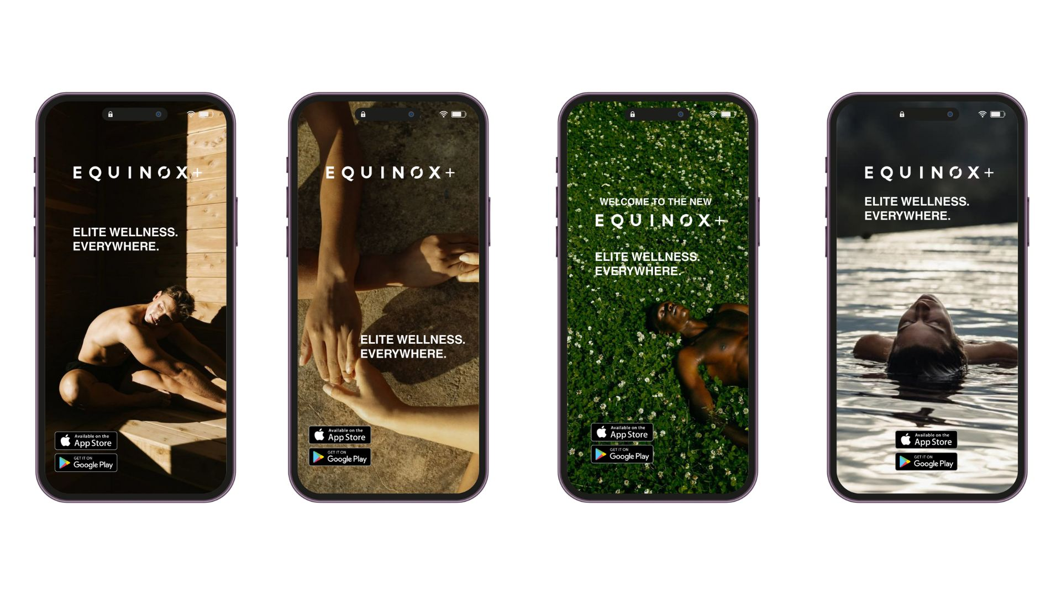

Exhibit 10 – Original Social Ad Campaign, May 2025

Exhibit 11 – Original Ad Campaign, May 2025



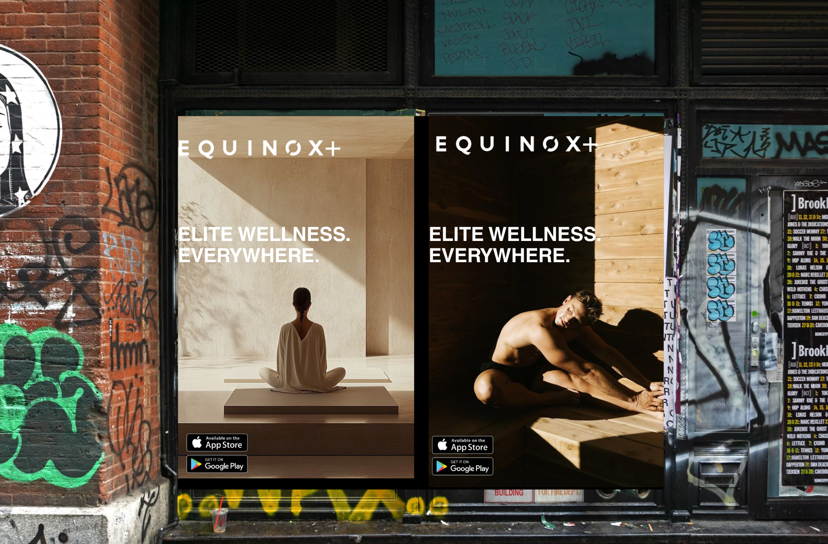

Exhibit 12 – Original Ad Campaign, May 2025

**References**

Aubrey Marketing. (2023). *Peloton marketing case study*.<https://aubrey-marketing.co.uk/introduction-course/peloton/>

Aziz, S. (2023). *Equinox: It's not fitness, it's lifeblood*. *The Physicality*.<https://thephysicality.substack.com/p/equinox-its-not-fitness-its-lifeblood>

Brand Innovators. (2022, November 2). *Peloton asserts it’s for everyone, everywhere*.<https://brand-innovators.com/peloton-asserts-its-for-everyone-everywhere/>

BrandVM. (2023, March 20). *Equinox’s strategic marketing decisions and controversial campaigns*.<https://www.brandvm.com/post/equinoxs-marketing>

BrandVM. (2023, March 30). *Peloton's rebranding and how it's shaping a fitness revolution*.<https://www.brandvm.com/post/pelotons-rebranding>

Braze. (2023). *Equinox builds dynamic app experiences at scale with Braze content cards*.<https://www.braze.com/customers/equinox-case-study>

Business of Apps. (2025). *Fitness app revenue and usage statistics (2025)*.<https://www.businessofapps.com/data/fitness-app-market/>

Businesswire. (2023). *Lululemon and Peloton announce five-year strategic global partnership*.<https://www.businesswire.com/news/home/20230927420138/en/lululemon-and-Peloton-Announce-Five-Year-Strategic-Global-Partnership>

CourseSidekick. (2023). *Consumer perception of Peloton brand: A comprehensive analysis*.<https://www.coursesidekick.com/business/175102>

Empathy Marketing. (2023, January 18). *Peloton’s brand positioning*.<https://www.empathymarketing.co/blog/peloton-brand-positioning>

Equinox. (2022). *Life is the luxury*.<https://www.equinox.com/landing/litl>

Equinox Careers. (n.d.-a). *What matters to us*.<https://careers.equinox.com/our-values>

Equinox Careers. (n.d.-b). *Who we are*.<https://careers.equinox.com/about>

Future Market Insights. (2025). *Global hyper-personalized fitness market set to reach USD 261,558 million by 2035*.<https://www.morningstar.com/news/accesswire/971359msn/global-hyper-personalized-fitness-market-set-to-reach-usd-261558-million-by-2035-growing-at-a-robust-cagr-of-189-future-market-insights>

Grand View Research. (2023). *Personalized wellness market size, share & trends analysis report*.<https://www.grandviewresearch.com/industry-analysis/personalized-wellness-market>

GreenBook. (2023). *The power of emotional needs in consumer purchases: Insights from two studies*.<https://www.greenbook.org/insights/research-methodologies/the-power-of-emotional-needs-in-consumer-purchases-insights-from-two-studies>

Jordan Bean. (2023, March 15). *Equinox Fitness: The analytics behind the high-end fitness club*. *Medium*.<https://jordanbean.medium.com/equinox-fitness-the-analytics-behind-the-high-end-fitness-club-dc9e4058ed00>

McKinsey & Company. (2022). *Sweating for the fitness consumer*.<https://www.mckinsey.com/industries/consumer-packaged-goods/our-insights/sweating-for-the-fitness-consumer>

McKinsey & Company. (2024). *The trends defining the $1.8 trillion global wellness market in 2024*.<https://www.mckinsey.com/industries/consumer-packaged-goods/our-insights/the-trends-defining-the-1-point-8-trillion-dollar-global-wellness-market-in-2024>

McMillanDoolittle. (2023). *More than a gym: Equinox provides aspirational lifestyle at a premium price*.<https://www.mcmillandoolittle.com/more-than-a-gym-equinox-provides-aspirational-lifestyle-at-a-premium-price/>

Media Culture. (2023). *Achievement meets adventure: The psychological profile of today’s wellness consumer*.<https://www.mediaculture.com/insights/achievement-meets-adventure-the-psychological-profile-of-todays-wellness-consumer>

Peloton. (2022). *Motivation that moves you*.<https://www.onepeloton.com/press/articles/motivation-that-moves-you>

Peloton. (2023). *Peloton reintroduces itself for anyone, everywhere*.<https://investor.onepeloton.com/node/10106/pdf>

Peloton Interactive. (2023). *Peloton Interactive*.<https://en.wikipedia.org/wiki/Peloton_Interactive>

ResearchGate. (2021). *A strategic analysis of Peloton*.<https://www.researchgate.net/publication/350589501_A_STRATEGIC_ANALYSIS_OF_PELOTON_2>

Retail Dive. (2022, October 11). *Peloton repositions itself as 'more than a bike company'*.<https://www.retaildive.com/news/peloton-fitness-rebrand-bike-gym-membership/651134/>

Rutledge, P. (2020). *The psychology of Peloton's appeal (or what keeps us riding)*.<https://www.pamelarutledge.com/the-psychology-of-pelotons-appeal-or-what-keeps-us-riding/>

Salesforce. (2022). *State of the connected customer* (5th ed.).<https://www.salesforce.com/resources/articles/state-of-the-connected-customer/>

Sheth, N. (2023). *How does Peloton make money?* Finty.<https://finty.com/us/business-models/peloton/?utm_source=chatgpt.com>

Vogue Business. (2023). *Why the “pink pilates princess” is actually a key consumer group*.<https://www.voguebusiness.com/story/fashion/why-the-pink-pilates-princess-is-actually-a-key-consumer-group>

We Are Collins. (2023). *We don’t speak January*.<https://www.wearecollins.com/work/we-dont-speak-january-campaign/>

Wegile. (2024). *Top 10 fitness app trends to watch in 2024*.<https://wegile.com/insights/top-10-fitness-app-trends.php>